How To Run MASM assembler on GUN/Linux

TOOLS:

- Wine
  - An app that use to run Microsoft windows on Linux and Mac.
  - Can be installed directly from - Ubuntu Software Center -

- SASM
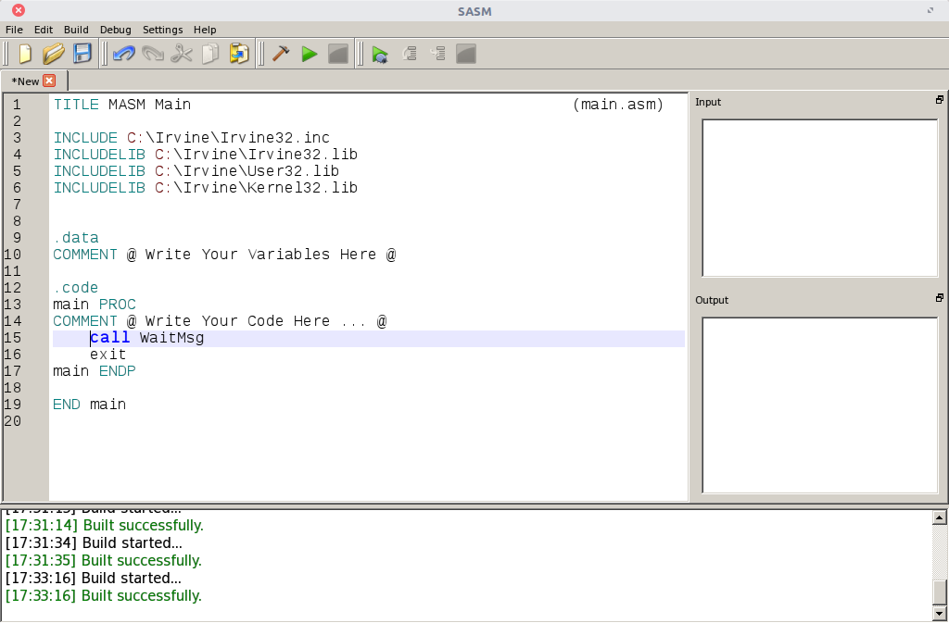
  - This will be the IDE that we will code on
  - We will use the windows version of this application
  - link - https://dman95.github.io/SASM/SASMSetup320.exe

- MASM
  - The assembler – This is something acts like a compiler
  - link - http://website.assemblercode.com/masm32/masm32v11r.zip
    - Extract and install it

- Irvine Libraries
  - These are the libraries of Irvine that we will use along our course
  - link - http://www.kipirvine.com/asm/examples/Irvine_7th_Edition.msi

Installation:

- Download all the previous links and install them.
- Open SASM
- Settings
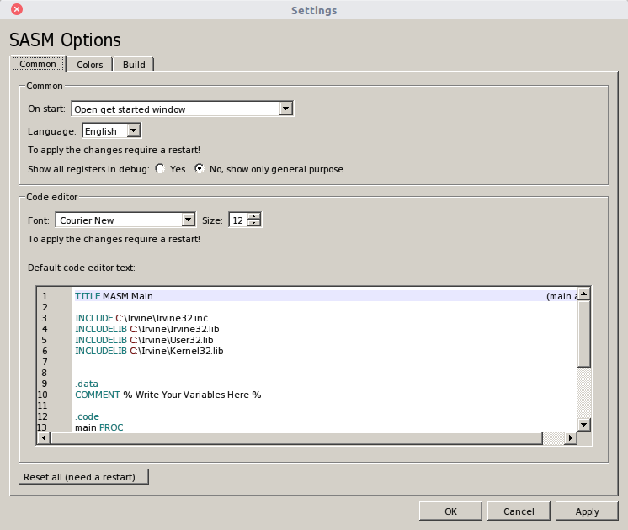

- At “default code editor text” .. replace it with:
TITLE MASM Main(main.asm)

INCLUDE C:\Irvine\Irvine32.inc
INCLUDELIB C:\Irvine\Irvine32.lib
INCLUDELIB C:\Irvine\User32.lib
INCLUDELIB C:\Irvine\Kernel32.lib

.data
COMMENT % Write Your Variables Here %

.code
main PROC
COMMENT % Write Your Code Here ... %

call WaitMsg
exit
main ENDP

END main

- Change the assembler into MASM

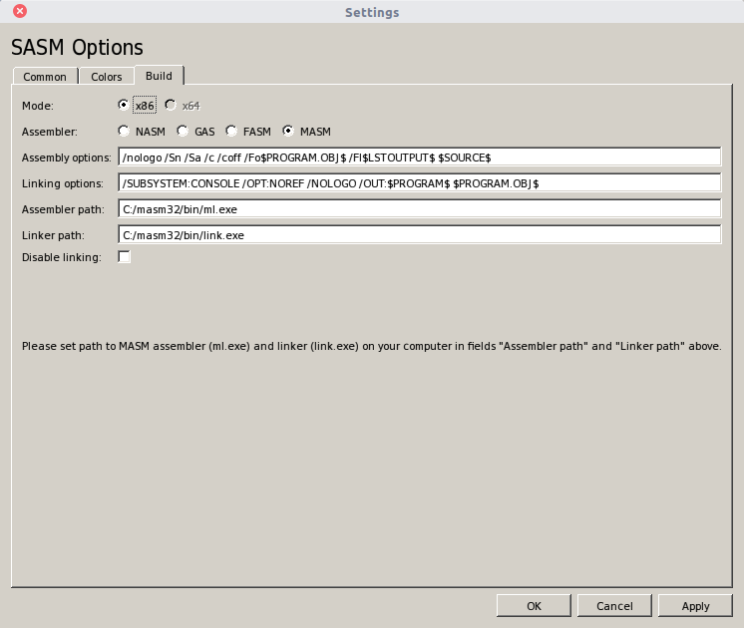
- Now press Apply then Ok
- from File > New

Assemble and Run:

- Build
  - press the build button

- Run
  - from Build > Run in new window
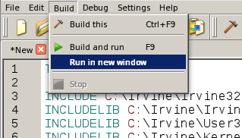

~ Enjoy ~

